Lab 1: Understanding ORM with a Retail Inventory System
1.What is ORM?
ORM stands for Object-Relational Mapping. In simple terms, it's a bridge between the way we think in code (objects and classes) and the way data is actually stored in a database (tables and rows).
Without ORM, if you wanted to fetch a product from a database, you'd have to write a SQL query by hand, send it to the database, get back raw rows of data, and then manually convert those rows into a C# object you can actually use in your program. That's a lot of repetitive, error-prone work.
ORM tools like Entity Framework Core take care of all that translation automatically. You define a regular C# class — say, a Product class with properties like Name and Price — and EF Core understands that this class corresponds to a Products table in the database. Each property on the class lines up with a column in that table, and each individual object you create in code represents one row of data.
So instead of writing SQL statements yourself, you just write normal C# code, and EF Core converts it into the right SQL behind the scenes. When you ask for a product, EF Core fetches the matching row and hands you back a fully-formed Product object, ready to use — no manual conversion needed.
Why this is useful:
- It saves time. You spend far less time writing boilerplate database code, since EF Core generates most of the SQL for you. This means you can build features faster.
- It's easier to maintain. If your data model changes — say you add a new field to a class — EF Core can help you update the database structure to match, instead of you having to rewrite SQL scripts by hand every time something changes.
- It hides the database complexity. As a developer, you mostly get to think in terms of objects and relationships, not raw SQL syntax. This makes the code easier to read, write, and reason about, especially for people who are more comfortable with C# than with writing complex queries.

2.EF Core vs EF Framework
Microsoft actually has two different versions of Entity Framework, and it's worth understanding why EF Core came along in the first place.
EF Framework — usually just called EF6 — was the original version. It's been around for a long time, so it's very stable and well-tested, and a lot of older enterprise applications still rely on it. The catch is that it only runs on Windows, and it was built before many modern development practices became standard. Because of that, it tends to feel a bit rigid compared to what developers expect today.
EF Core, on the other hand, was built from the ground up as a more modern alternative. The biggest difference is that it's cross-platform — you can run it on Windows, Linux, or macOS, which matters a lot now that so many applications get deployed to cloud environments or containers that aren't necessarily Windows-based. It's also designed to be lighter and faster than EF6.
Beyond just being cross-platform, EF Core was built to take advantage of newer C# and .NET capabilities. It has much better support for things like:
- LINQ improvements, making it easier and more natural to write queries directly in C#
- Async queries, so database calls don't block your application while waiting for a response — this is especially important for responsive, scalable applications
- Compiled queries, which let you pre-build certain queries ahead of time so they execute faster when called repeatedly
So the general trade-off comes down to this: EF6 is older and more mature, with a long track record, but it's stuck on Windows and doesn't take advantage of newer .NET features. EF Core is newer, more flexible, faster, and runs anywhere — which is exactly why it's become the standard choice for new projects today, including the labs we're working through here.
3.EF Core 8.0 Features
Each new version of EF Core tends to bring in features that make it faster and more capable, and EF Core 8.0 is no exception. A few of the standout additions are worth understanding:
JSON column mapping — Sometimes not all your data fits neatly into traditional rows and columns. For example, you might have a product with a flexible set of attributes that vary from item to item, and forcing that into separate columns would be messy. EF Core 8.0 lets you store this kind of data directly as JSON inside a single SQL Server column, and still query and work with it through your normal C# objects. This gives you the flexibility of JSON without losing the structure and querying power of a relational database.
Improved performance with compiled models — Normally, when your application starts up, EF Core has to do some work behind the scenes to understand your data model — the classes, their relationships, and how they map to tables. This process can take a little time, especially in larger applications. With compiled models, that mapping information can be pre-generated ahead of time and baked into your application, so EF Core doesn't have to figure it all out fresh every time the app starts. The result is noticeably faster startup performance, which matters a lot for applications that need to scale or restart frequently.
Interceptors and better bulk operations — Interceptors give you a way to "hook into" what EF Core is doing internally — for instance, you could intercept a command right before it's sent to the database, log it, modify it, or even cancel it. This is useful for things like auditing, logging, or enforcing custom rules across your whole application without repeating that logic everywhere. On top of that, EF Core 8.0 also improved how it handles bulk operations, meaning tasks like updating or deleting large numbers of records at once perform better than in earlier versions, which previously could be a noticeable bottleneck.
Together, these features show the general direction EF Core is moving in: more flexibility (with JSON), better performance (with compiled models and bulk operations), and more control over what's happening under the hood (with interceptors).

4. Create a .NET Console App
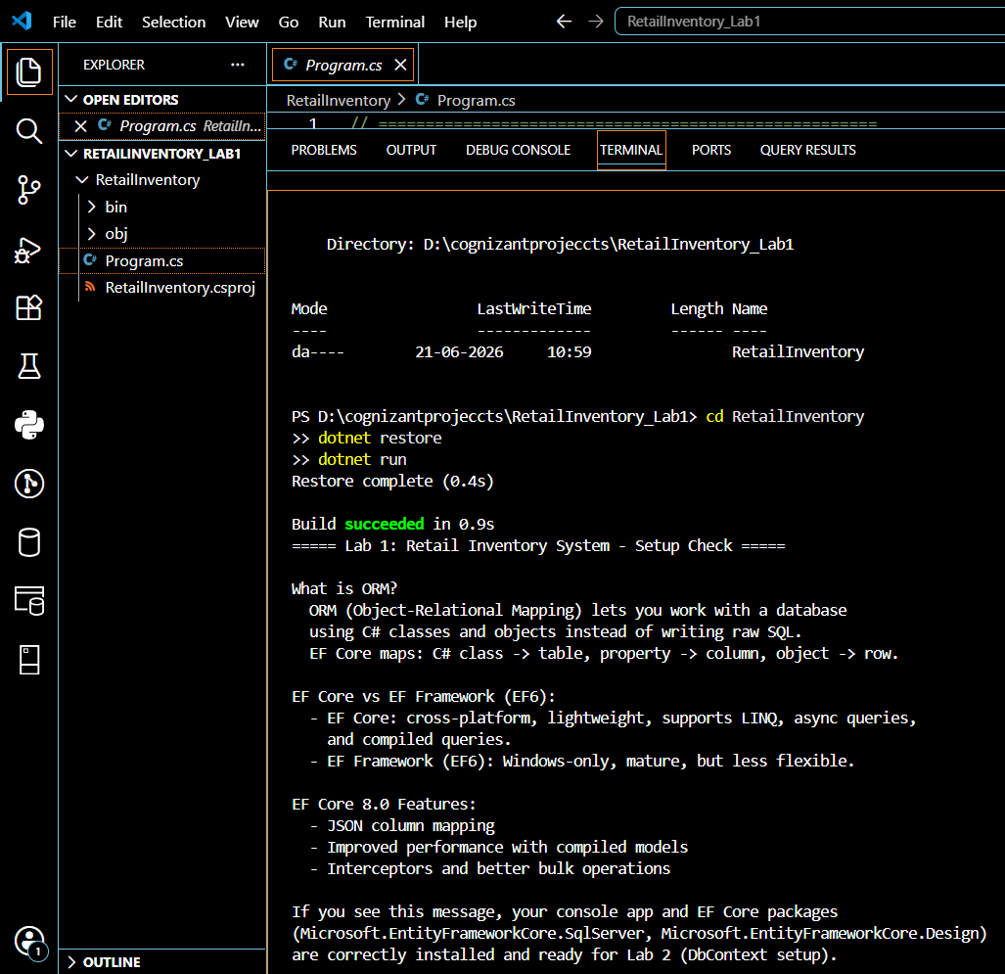
5. Install EF Core Packages:


